Saturn and Neptune Home Learning

English

Write a description of the picture. Think about the different types of sentences you know. Can you use some fronted adverbials (e.g. On the wintry lane, …..) to start some of your sentences? Think about the adverbs you choose, you could use [Thesaurus and Word Tools | WordHippo](https://www.wordhippo.com/) to help up level your choices.

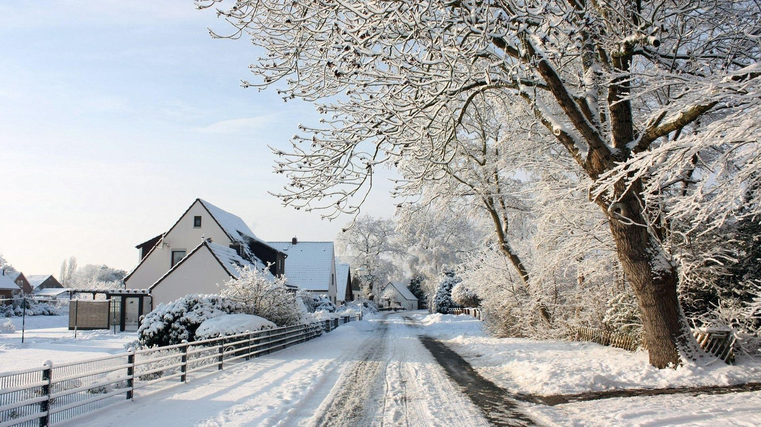

Maths

Please login to LBQ <https://www.lbq.org/> (the children use this lots, so they will know how to login)

You will find a place value topic review lesson, one for Year 3 and one for Year 4.

The code for the lesson is **nsrg**

(Task 1 = Y3, Task 2, Y4)

Then login to **TTRS.**

Whole Class Reading

Please write a book review for either your favourite book or one you have read over the holidays. Please see the example below but feel free to use any template of your choosing.

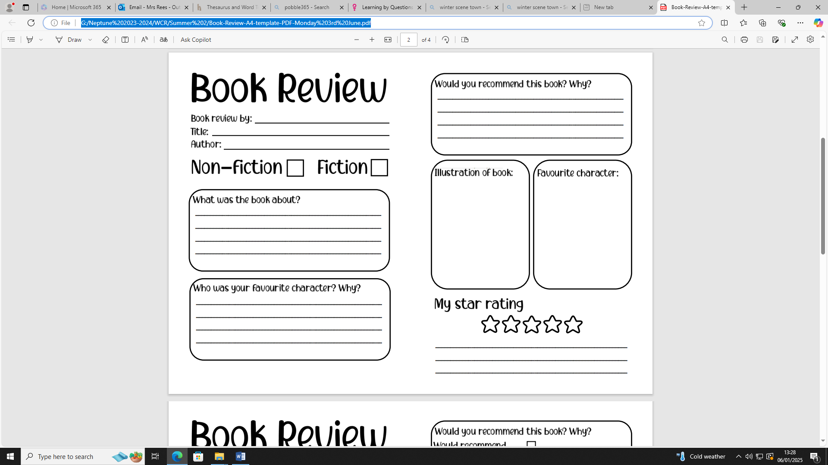

Science

We are going to be starting our new topic about light. We would like the children to create a poster about what they already know about different light sources. Be as creative as you like!