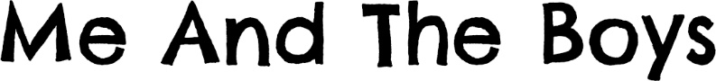

**Verse 1** Me and the boys, just waiting in line,

Smiles all around and ready to sign.

Up for the effort, together,

Just me and the boys.

We kissed our girls as the train left that day,

Off to a foreign land far, far away.

For king and for country, together,

Just me and the boys.

***Chorus*** *And we’ll be back by Christmas,*

*That’s what we thought.*

*On and on in the war to end wars.*

**Verse 2** Me and the boys, though our numbers decline,

Out in the trenches we wait for the sign

To pick up our rifles together,

Just me and the boys.

And we dream of the day when all this is done,

The guns will fall silent and battle is won

And we’ll share in our stories, together,

Just me and the boys.

***Chorus*** *And we’ll be back by Christmas,*

*That’s what we thought.*

*On and on in the war to end wars.*

**Verse 3** Me and the boys, although now it’s just me,

Walk down the lane to see our families

And I’ll tell them all of the bravery

Shown by those boys.

’Cause they gave their lives so that we could be free

And so we pay tribute to their memory.

We’ll pin on our poppies remembering

Me and the boys.

***Chorus*** *And we’ll be back by Christmas,*

***That’s what we thought.*

*They gave it all in the war to end wars.*

*They gave it all in the war to end wars.*