 |  |  |  |  | 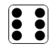
nose | theme | bike | kite | complete | extremely
slide | cone | compete | drove | home | five
these | like | alone | extreme | alive | joke

Choose one of the words above to write in a sentence.




