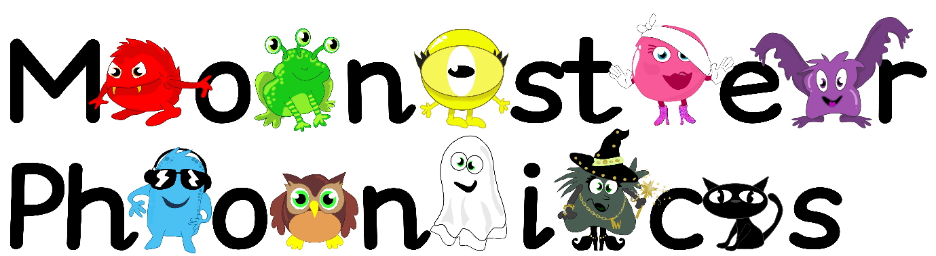

Friday 11th October 2024

Dear Parents/Carers,

**We have been learning the following sounds:**

o c k ck

**High Frequency Words:**

to into no go the

**Phonics Activity**

Practise writing or making the graphemes for the sounds we have learnt so far. There are lots of ways this can be done – get creative!

The graphemes we have learnt so far are…

s a t p i n m d g o c k ck

There are some ideas on the second page of how you could make or write these graphemes! Please send any photos to our email.

We appreciate this learning being reinforced at home.

Please return your homework folder to school by **Thursday 17th October 2024.**

Kind regards,

Miss Pomfret and Miss Cummins

