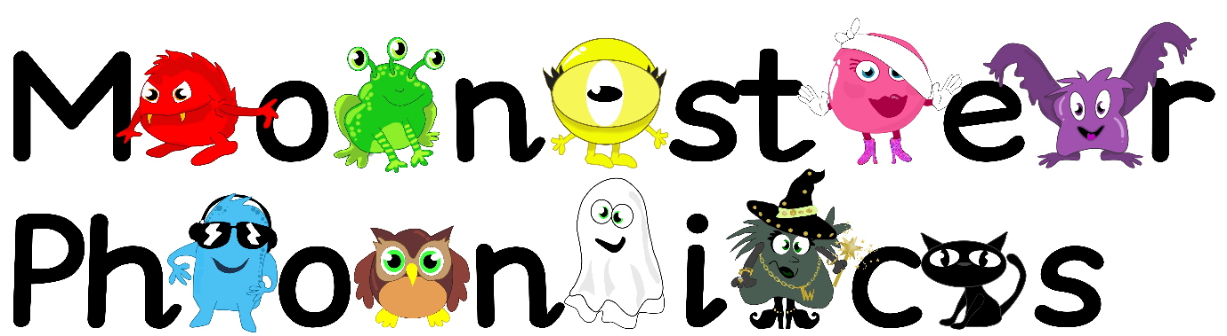

Friday 27th September 2024

Dear Parents/Carers,

**We have been learning the following sounds:**

s a t p i n

**High Frequency Words:**

at as an it is in I

**Phonics Activity**

Cut up the grapheme and high frequency word flashcards and have a phonics disco! Place the cards on the floor around the room and dance to your favourite music. When the music stops, jump on a card and read the grapheme or high frequency word that you have landed on.

We appreciate this learning being reinforced at home.

Please return your homework folder to school by **Thursday 3rd October 2024.**

Kind regards,

Miss Pomfret and Miss Cummins

|  |  |  |
| --- | --- | --- |
| s | a | t |
| p | i | n |
| at | as | an |
| it | is | in |
| I | | |