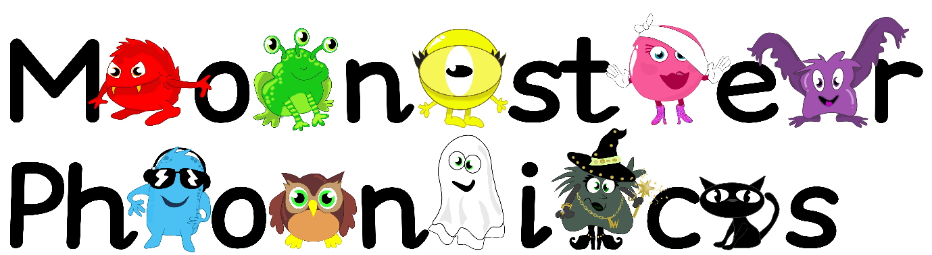

Friday 4th October 2024

Dear Parents/Carers,

**We have been learning the following sounds:**

m d g

**High Frequency Words:**

and dad am

**Phonics Activity**

Cut up out the CVC word flashcards. Use your phoneme finger to press the sound buttons as you say each sound. After segmenting (sounding out) the word, blend it back together to hear the full word. For example, s-a-t sat or n-i-p nip. Don’t forget to smooth word read after blending to support fluency.

We appreciate this learning being reinforced at home.

Please return your homework folder to school by **Thursday 10th October 2024.**

Kind regards,

Miss Pomfret and Miss Cummins

sat

nip

mat

nag

dig