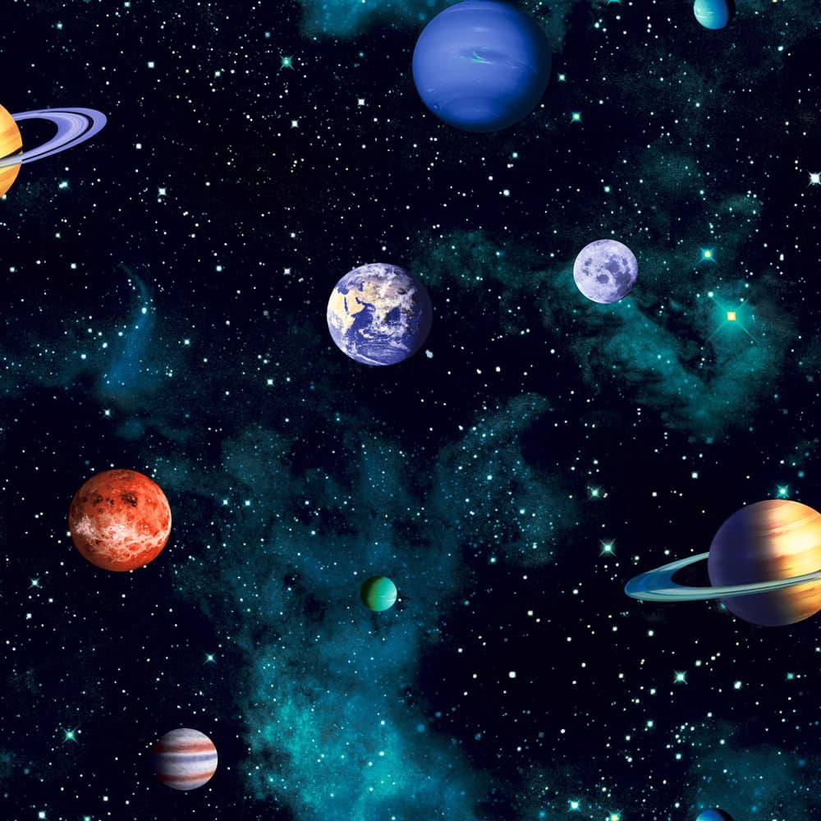

To know decimal number bonds to 1.

For example:

0.2+0.8=1

To identify prime numbers to 20.

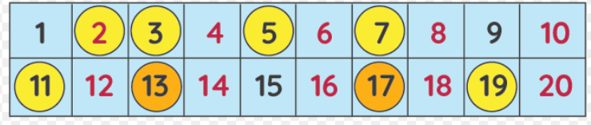

To recall square numbers up to 12.

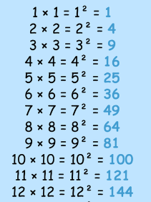

.

**Congratulations, you have achieved the Planet certificate.**

To find factor pairs of a number.

For example:

Factor pairs of 28: 1 and 28, 2 and 14, 4 and 7

To recall all times table and division facts up to 12 x 12.

**Congratulations, you have achieved the Rocket certificate.**

The gameboard encourages regular focus on key Maths skills. Certificates will be awarded for every two space missions completed.

Good luck.

**Congratulations, you have achieved the Galaxy certificate.**

To recognise decimal and percentage equivalents of the fractions ½, ¼, ¾,1/3, 2/3

**Mission in Maths**

**Year 5**