

The gameboard encourages regular focus on key Maths skills. Certificates will be awarded for every two space missions completed.

Good luck.

To know the multiplication and division facts for the 8 times table, up to 12 x 8.

Count up and down in tenths.

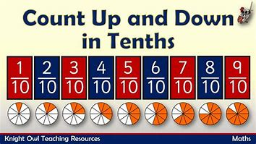

**Congratulations, you have achieved the Galaxy certificate.**

**Congratulations, you have achieved the Planet certificate.**

To know the multiplication and division facts for the 3 times table, up to 12 x 3.

To count forwards and backwards in:

2s and 20s

(Start at different numbers, not just 0. For example, count from 68 in 2s).

To count forwards and backwards in:

5s, 50s and 25s

(Start at different numbers, not just 0. For example, count from 45 in 5s).

To know the multiplication and division facts for the 4 times table, up to 12 x 4.

**Year 3**

**Congratulations, you have achieved the Rocket certificate.**

**Mission in Maths**