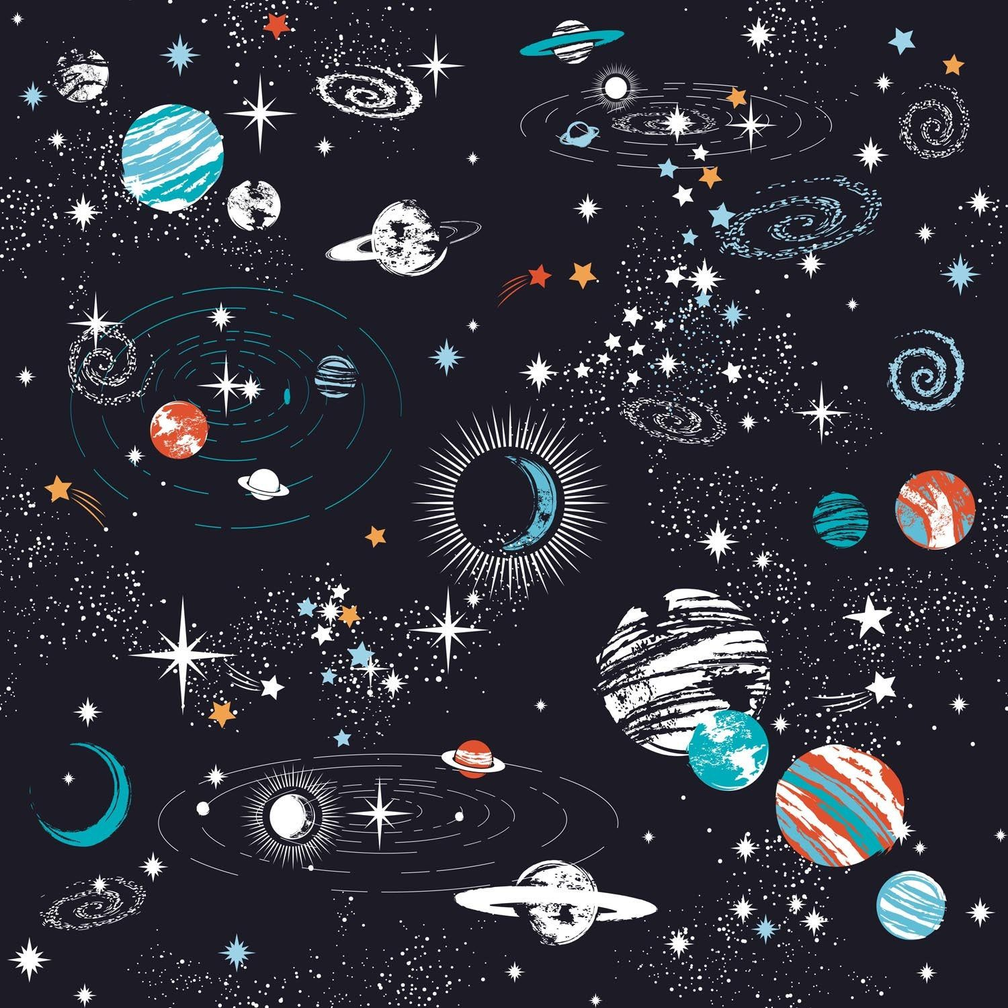

To multiply and divide 1 and 2 digit numbers by 10 and 100.

To know number bonds to 100.

For example: 80 + 20, 70+30

71+29, 57+ 43

The gameboard encourages regular focus on key Maths skills. Certificates will be awarded for every two space missions completed.

Good luck.

To recognise decimal equivalents of the fractions ½, ¼, ¾

To know the multiplication and division facts for the 7 and 11 times tables, up to 12 x 7 & 12 x 11.

.

To know the multiplication and division facts for the 6 and 9 times tables, up to 12 x 6 & 12 x 9.

**Congratulations, you have achieved the Galaxy certificate.**

To recall all times table facts up to 12 x 12.

**Year 4**

**Congratulations, you have achieved the Rocket certificate.**

**Congratulations, you have achieved the Planet certificate.**

**Mission in Maths**